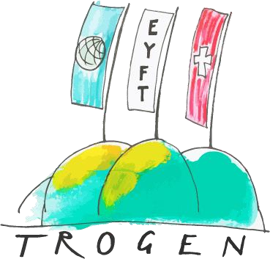



# Our hosts: Kantonsschule Trogen and Pestalozzi Children’s Foundation

The **Kantonsschule Trogen** (KST) was founded nearly 200 years ago, in 1821. It is the only high school in the canton of Appenzell Ausserrhoden. With about 700 students it is a rather small school. However, it has the advantage that people know each other and that there are familiar faces everywhere. Despite its small size, the school not only offers classical high school education, but also has a business school and a health/sociology/pedagogy school in which educational training and practical work are combined. The Kantonsschule Trogen has a renowned music department and works in cooperation with a talent school for sports. The school has a strong international focus, with many languages being taught, from Latin, French, Italian and English to Russian and Chinese, and runs many exchange programs on a national and international level. It also offers the possibility of a bilingual education with English or French (and German). [www.kst.ch](http://www.kst.ch/)

The **Pestalozzi Children's Foundation** (PCF) is an international children's charity. Its focus has been on children and young people since it was founded in 1946, following world war II. The Children’s Village in Trogen is a place where children from Switzerland and other countries learn to build peace through the exchange of experiences and are taught to understand cultural and social differences. The Foundation provides children with access to good quality education in eleven countries worldwide. [www.pestalozzi.ch](http://www.pestalozzi.ch/) & [www.facebook.com/kinderdorfpestalozzi](http://www.facebook.com/kinderdorfpestalozzi)

|  |  |
| --- | --- |
| Pestalozzi Children`s Foundation | Kantonsschule Trogen |
| Kinderdorfstrasse 20 | Kantonsschulstrasse 23 |
| 9043 Trogen | 9043 Trogen |
| Switzerland | Switzerland |

Additional information can be found on our website [www.eyft.eu.](http://www.eyft.eu/)