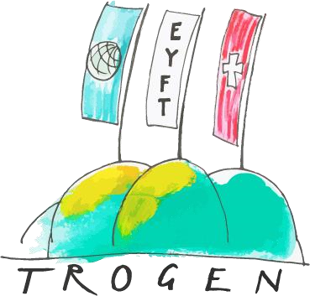



**European Youth Forum Trogen: “Building Europe’s Future”**

This year, around 154 high school students from different European countries will meet in Trogen, Switzerland for a week of discussion and debate on current social and political issues and challenges. The EYFT is coorganised by the Kantonsschule Trogen and by the Pestalozzi Children’s Foundation.

## Participating schools

Schools from the following countries will participate at the European Youth Forum Trogen 2020:

Poland, Croatia, Hungary, Ukraine, Russia, Italy, Latvia, Turkey, Germany, Switzerland and Scotland.

Each school will send a delegation of 14 students and 2 accompanying teachers.

## Programme of the week

|  |  |
| --- | --- |
| **Sat. 29/02/2020** | Arrival of the delegations at the Children’s Village between 1pm and 4pm. Opening ceremony: Presentation of the delegations. |
| **Sun. 1/03/2020** | Choose your workshop and get to know each other. |
| **Mon. 2/03/2020** | Topics are studied and discussed in the workshops. |
| **Tue. 3/03/2020** | Diving deeper into the chosen topic. |
| **Wed. 4/03/2020** | Excursion with all participants to the Säntis (mountain) |
| **Thu. 5/03/2020** | The different workshops present their results. |
| **Fri. 6/03/2020** | General Assembly and presentation of the action plans (what's your action for a better future?) |
| **Sat. 7/03/2020** | Departure |

**The main goals of this project are:** a European intercultural exchange, personal development of the participants, and engaging in constructive debates.

**The impact of the European Youth Forum** will last for much longer than a week, since the delegates will be empowered to put their skills and knowledge into action in their home schools and communities. A website makes the results available to the other schools and links the different projects. All results and impressions of the past EYFT can be found under [www.eyft.eu.](http://www.eyft.eu/)

## Approach and teaching methods

The participants will choose from different workshops depending on their interests and expertise and mix with people from different countries. The courses will be led by experienced teachers and pedagogues from the Kantonsschule Trogen and the Pestalozzi Children’s Foundation. The teaching approach is child-centred and experienced-based. Participants will be encouraged to share their ideas and visions with their peers and will be empowered to make change happen. To ensure knowledge transfer from Trogen to their home countries, participants will plan an action that they will implement in their schools and communities when they return home.

**Some of the workshop topics are:**

## Women's Equality

In Switzerland we tend to take it for granted that men and women are treated equally. This workshop, which is definitely not just for women, will take a look at the situation in the participating countries, exploring differences and similarities. Through roleplays we will try to break down stereotypes and empower women – and men!

**Workshop: The Climate Crisis**

Melting glaciers, rising sea levels and millions of young people taking to the streets to demand immediate action against climate change. Against this backdrop, our workshop aims to equip participants with an understanding of the science and politics of climate change and to empower them to take direct action against it. By exchanging our knowledge, experience and views and through various approaches such as debate, theatre and fun cooperative games, we are going to piece together the puzzle of climate change and find out how to face it. Because when it comes down to it, the future of Europe - and of the entire world - depends on the way we are facing the climate crisis.

**Boarders**

The workshop aims to explore the idea of borders and meetings across borders in a multicultural and globalized world. How can we reflect on this fundamental topic without falling into facile stereotypes?

In the workshop we will explore different approaches to the concept of borders through the use of words and music.Thereby the workshop-topic will not only be a subject for theoretical reflection or debate, but also become a tangible experience.

**Finding the truth**

In a fun-oriented, fast-moving society, fake news are becoming more and more popular. How to decipher false information and where to find the answers to the really big questions?

Combining your profound personal insights with experimenting different media tools, we will go on a treasure hunt for "the truth"!